HEALTH AI - INTELLIGENT HEALTHCARE ASSISTANT

# Project Documentation

# 1. Introduction

Project title: Health AI – Intelligent Healthcare Assistant

Team members:

1. Dhanalakshmi A(Team leader)
2. Chandhanapriya p
3. Chenchu Lakshmi PC
4. Deepika V

# 2. Project Overview

## Purpose:

HealthAl is designed to provide smart, easy-to-understand healthcare assistance using Graniter models from Hugging Face. It enables patients to interact through natural conversations, receive predictions about possible diseases, and get recommended treatment plans. By leveraging Al and Gradio powered interfaces on Google Colab, HealthAl ensures fast, accessible, and secure medical guidance for both patients and healthcare providers.

Features:

-Patient Chat (Natural language healthcare support)

Disease Prediction (Early detection support)

Treatment Plan Suggestions (Actionable medical recommendations)

Secure & Accessible Deployment (Google Colab support)

## Features:

* **Disease Prediction**: Users can input a list of symptoms and receive a list of possible medical conditions and general medication suggestions.
* **Personalized Treatment Plans**: Based on a user's stated condition, age, gender, and medical history, the system provides generalized treatment suggestions, including home remedies.

# 3. Architecture

Frontend (Gradio): Interactive and user-friendly web Ul.

Backend (Google Colab FastAPI optional). Hosts model execution and integrates Granite models

Al Model (IBM Granite-Hugging Face): Natural language understanding, disease prediction, and

response generation.

# 4. Setup Instructions

## Prerequisites:

* Python 3.7+ – Required to run the project.
* Libraries: gradio, torch, transformers
* Hardware: The ibm-granite/granite-3.2-2b-instruct model requires significant resources. A GPU with at least 8GB of VRAM is highly recommended for faster inference. CPU-only execution is possible but will be very slow.
* Internet: Required to download the model files from the Hugging Face Hub.

## Installation:

• Python 3.7+ – Programming environment.

• PyTorch – Deep learning framework (with optional CUDA support for GPU).

• Hugging Face Libraries – transformers , gradio

# 5. Folder Structure

project-root/  
│── health_ai.py # Main application script  
│── Requierments.txt # Dependencies  
│── README.md # Documentation

# 6. Running the Application

* Save the provided code as a Python file (e.g., health_ai.py).
* Open a terminal or command prompt.
* Run the application with the command: python health_ai.py
* The application will start, and a local URL

# 7. API Documentation

Currently only available through the Gradio UI. Future versions may expose FastAPI endpoints.

# 8. Authentication

Open app runs without authentication for demo purposes.

Future enhancements may include login, role-based access, and teacher/student accounts.

# 9. User Interface

**Technology**: Gradio

**Functionality**:

This layer provides the front-end interface where users can interact with the application through text boxes and buttons. It manages the input of symptoms and patient information and displays the generated AI responses.

# 10. Testing

* Unit Testing: Check individual functions like AI response generation and data handling.
* Integration Testing: Verify that frontend (HTML/CSS) and backend (Flask + AI) work together.
* Performance Testing: Ensure AI responses are fast and system handles multiple users.
* Debugging: Identify and fix errors in backend, frontend, or AI modules.
* Final Validation: Confirm the app works smoothly before deployment.

# 11. Screenshots

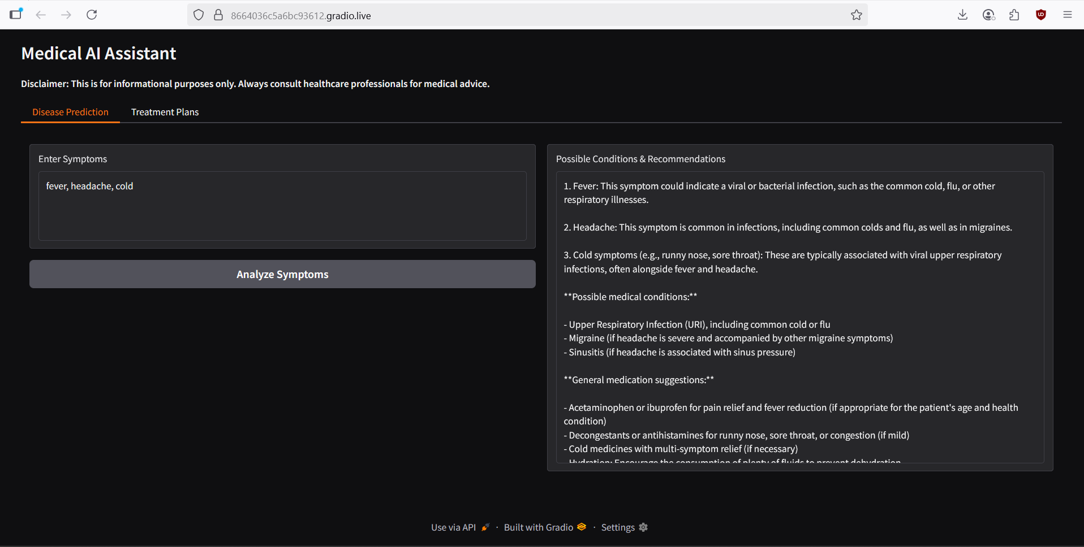

# 12. Known Issues

* High resource usage – Large AI models require lots of RAM/VRAM.
* Slow CPU performance – Responses are slower without GPU.
* Lack of Persistence - The application does not store any user history or data. Each interaction is a new, isolated request.
* AI Model Limitations - The AI may occasionally provide inaccurate, irrelevant, or non-specific information. It is crucial to remember this is a general-purpose model and not a specialized medical tool.

# 13. Future Enhancements

* **Specialized Fine-Tuning**: Fine-tune the language model on a curated medical dataset to improve accuracy and specificity.
* **Persistent User Sessions**: Implement a database (like Firebase Firestore) to store user history (with proper security and anonymization) to provide more contextually aware responses.
* **Mobile and Web Access**: Develop a standalone mobile app or a more robust web interface using frameworks like React or Angular for better user experience.
* **Integration with Medical Databases**: Connect the assistant to external, trusted medical databases for more accurate information.